**Task 05**

**Name: Abdullah Butt** **Roll Number: 018**

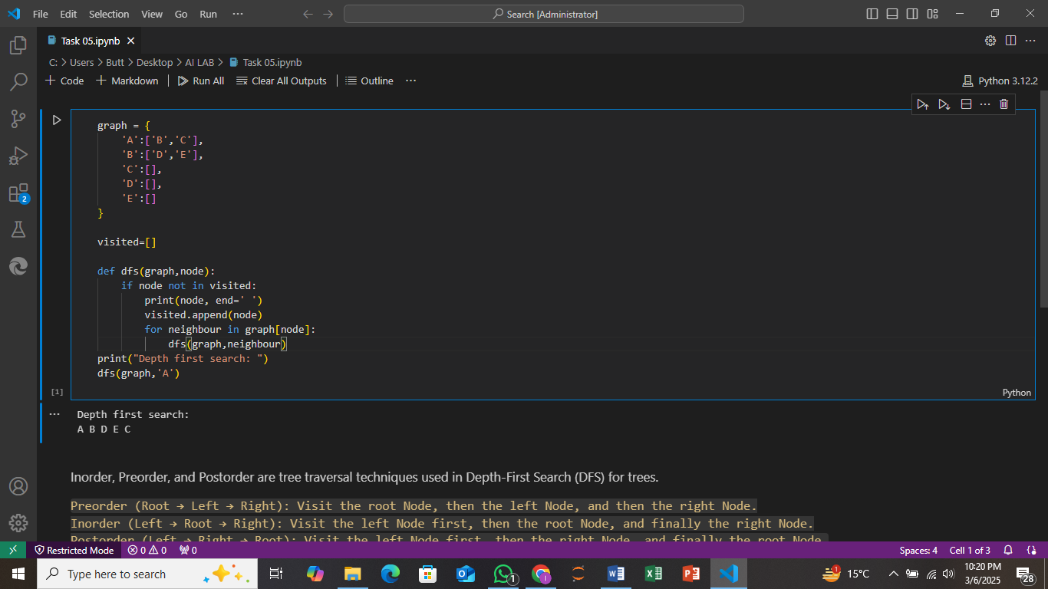

The graph is a dictionary where each key is a node, and the value is a list of its neighbors.An empty list (visited) is used to keep track of nodes that have already been visited during the traversal. The DFS function is used to perform a depth-first search on the graph. It

1. Prints the current node if it hasn't been visited.
2. Adds the node to the visited list.
3. Recursively visits all the neighbors of the current node.

The DFS starts from node 'A', and the function explores its neighbors recursively, visiting each one until all nodes connected to 'A' are visited.

**OUTPUT:**

The program will print the nodes in the order they are visited in a depth-first manner, starting from 'A'.

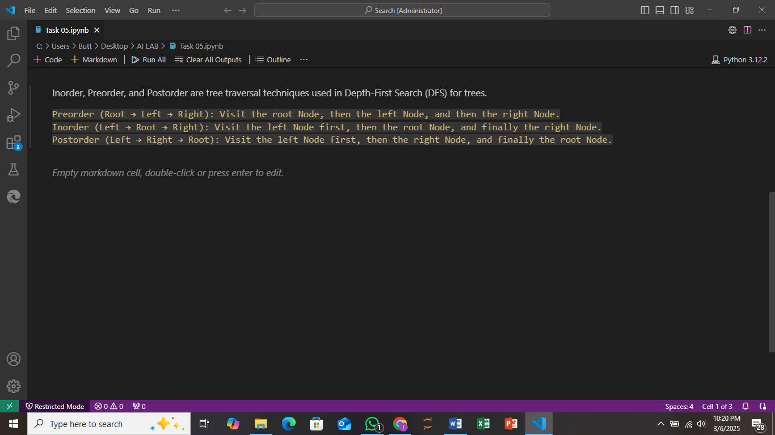

In this Task we describe the flow of execution in tree as in given below:

* Pre order: In preorder we move to Root node then toward left node and then right node.
* In order: In in order we move to left node first then toward root node and then right node.
* Post order: In post order we move toward left node in first then toward right node and then left node